EVIDENCE 2D: CREATING A 'TRAY LIST AMENDMENT' ON THE DEPARTMENT'S Q-PULSE SYSTEM (Step One)

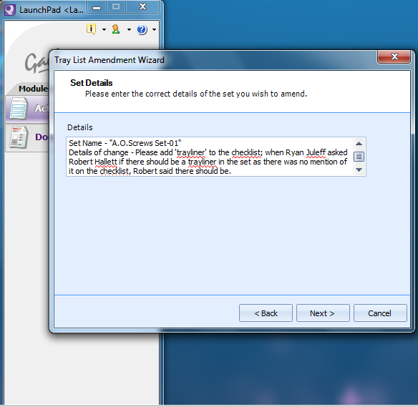

EVIDENCE 2D: CREATING A 'TRAY LIST AMENDMENT' ON THE DEPARTMENT'S Q-PULSE SYSTEM (Step Four)

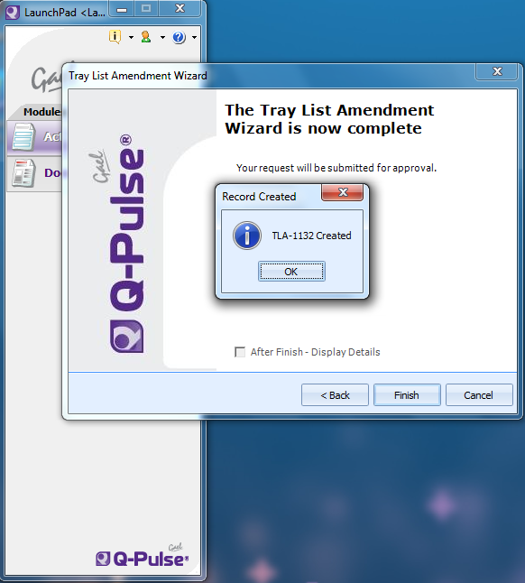

EVIDENCE 2D: CREATING A 'TRAY LIST AMENDMENT' ON THE DEPARTMENT'S Q-PULSE SYSTEM (Step Two)

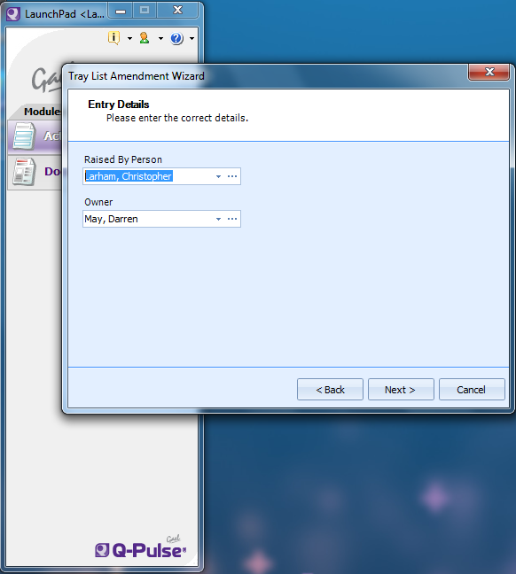

EVIDENCE 2D: CREATING A 'TRAY LIST AMENDMENT' ON THE DEPARTMENT'S Q-PULSE SYSTEM (Step Three)

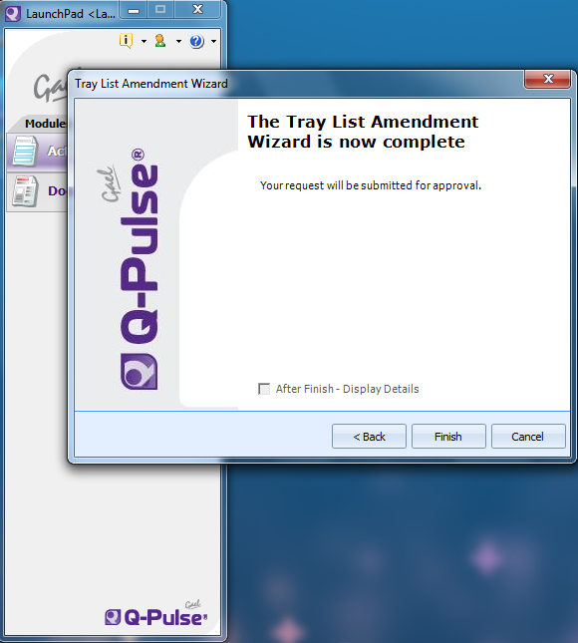

EVIDENCE 2B: CREATING AN 'EXTERNAL NON-CONFORMANCE' ON THE DEPARTMENT'S Q-PULSE SYSTEM (Example One - Damaged Items Removed By Theatre Staff)

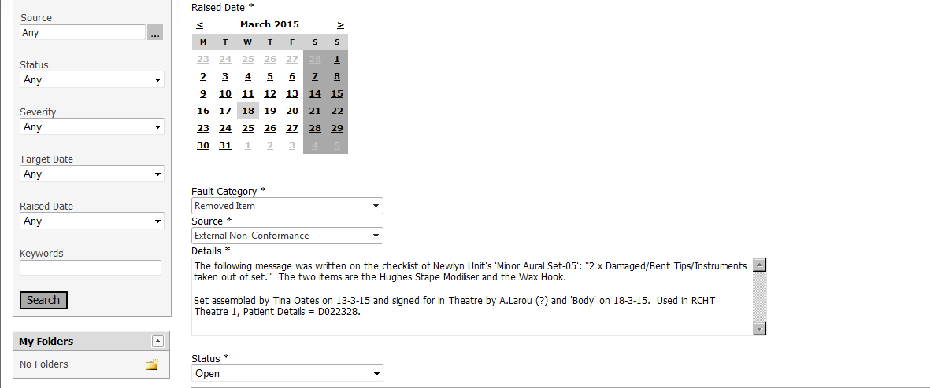

EVIDENCE 2B: CREATING AN 'EXTERNAL NON-CONFORMANCE' ON THE DEPARTMENT'S Q-PULSE SYSTEM (Log Number For Example One)

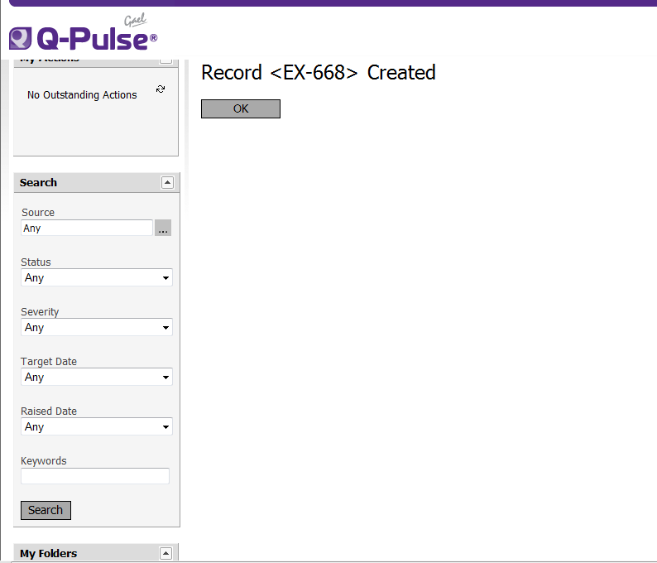

EVIDENCE 2C: CREATING AN 'INTERNAL NON-CONFORMANCE' ON THE DEPARTMENT'S Q-PULSE SYSTEM (Missing Instrument)

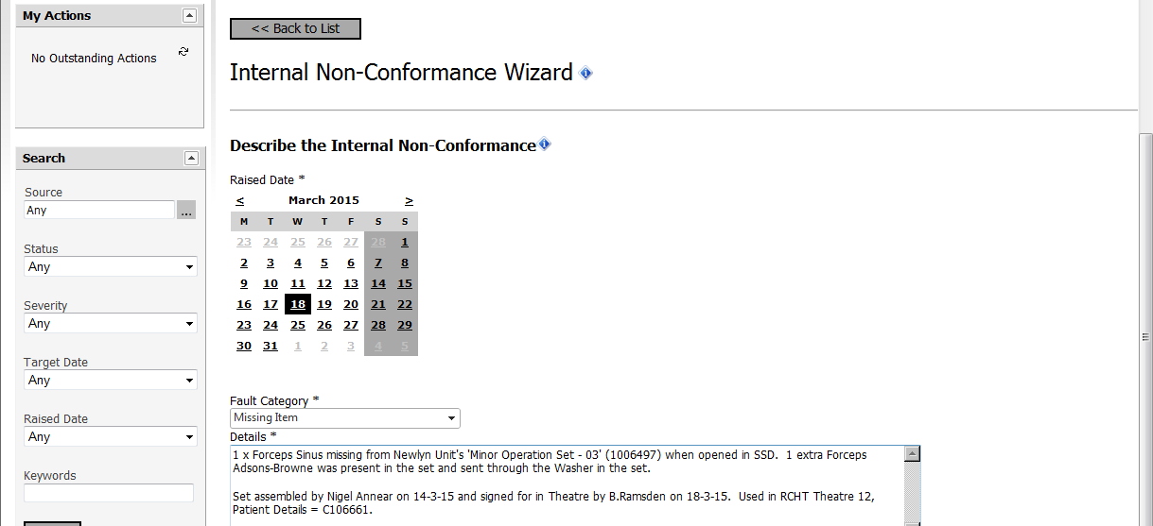

EVIDENCE 2B: CREATING AN 'EXTERNAL NON-CONFORMANCE' ON THE DEPARTMENT'S Q-PULSE SYSTEM (Example Two - Instrument Replacement)

